Student Number: 209124116
10th January 2022
Assessment Three: Research Report
SSC5002M
What factors influence whether people contact their Police and Crime Commissioner?
Contents

Introduction………………………………………………………………… 2

Literature Review…………………………………………………………..2

Methodology………………………………………………………………..4

Results………………………………………………………………………5

Discussion…………………………………………………………………12

Conclusion…………………………………………………………………12

Reference List……………………………………………………………..14

What is the effect of sex, ethnicity, and household income on whether people contact their Police and Crime Commissioner?

Introduction
Citizens can express their opinions on the criminal justice system easily and effectively by contacting their local Police and Crime Commissioner (Loader and Muir, 2016) - henceforth PCC. PCCs provide a crucial service, as they appoint Chief Constables, set police and crime objectives, and hold the police publicly accountable (Raine and Kessey, 2012). Therefore, allowing the public to discuss which crimes are prioritized, how resources are allocated, or police efficacy with their PCCs serves a key democratic purpose. Despite this - as Caless and Owens (2016) note in their exhaustive literature review - no significant analysis of the communication between PCCs and the public has yet been undertaken.
Discovering whether some groups are more likely than others to contact their PCC is of significant criminological importance. The Stevens Report (2013) states that PCCs often shape policies designed to please both the demographics that vote in PCC elections, and demographics that are most likely to contact PCCs. The Report even suggests that because ethnic minorities are less likely to vote in elections, policies are often made at their expense – for example, choosing to ignore discriminatory stop and search police tactics. Therefore, understanding which groups of people contact their PCC is of crucial importance, as research suggests that this influences the policies that govern that area.
This research report will explore how sex, ethnicity and household income affect whether a person contacts their PCC. A logistic regression analysis will be conducted to test whether there is any association between the above variables contained within the Crime Survey of England and Wales 2017-2018.

Literature Review
As previously stated, there is an alarming dearth in the literature examining the relationship between the PCCs and the public, and a systematic understanding of who contacts their PCCs is still lacking. Many academics have commented on this paucity of research (Kirkland, 2015; Caless and Owens, 2016), and they agree that the role of PCC is so new that there has not been enough time to examine them fully. PCCs were introduced by the Police Reform and Social Responsibility Act 2011, and consequently only three elections have since taken place.
There does, however, exist a wealth of literature on the efficacy of PCCs; with the academic consensus being that PCCs are ineffective and problematic. Crawford (2016) states that PCCs too often focus on community-led policing, and neglect more pressing major crimes. Alternatively, Kirkland (2015) suggests that PCCs fail to engage with the public, which is supported by recent devastatingly low election turnout - in 2012 the PCC election turnout was 14.7%, the lowest ever recorded for a national election. Furthermore, the Stevens Report (2013) states that the lack of diversity among PCCs impedes their ability to accurately represent their communities. More recently, McDaniel (2018) concluded that the police and crime plans made by PCCs are rarely based on community needs, and suggests that lack of public input is causing this.
As very little research exists exploring the communication between PCCs and different sexes, ethnicities and income levels; in this section of the report, research analysing the relationship between the public and the police will instead be explored. As PCCs are the public figureheads of the police, create plans of how the police will act, and are very often ex-police officers themselves (Roycroft, 2016), some academics have suggested there exists a link between how the public chose to communicate with the police, and with PCCs (Wells, 2018).
When researching the interactions between the police and different genders, the literature identifies sexual abuse reporting from both male and female victims as a key area of concern. Waterhouse, Reynolds and Egan (2016) state that women are unlikely to report sexual abuse and link this to a lack of confidence in the police – they argue that women think police will be sceptical and unempathetic. Studies also suggest that women may be correct to exhibit this mistrust, as police officers are likely to believe rape myths – for example, that a woman is “asking for it” if she is dressed in a certain way (Goodman-Delahunty and Graham, 2011; Sleath and Bull, 2012). Similarly, Weare (2021) explores reporting of sexual abuse from male victims, concluding that victims often believe that police will not accept the existence of such crimes, much less investigate them.
This literature shows a serious and detrimental lack of understanding from the police, and as Merry et al. (2012) shows, an effective way to counter this is to allow the public to communicate openly with police forces. Contacting PCCs is a way of giving men and women this channel of communication. Taylor and Gassner (2010) further support this notion – stating that a key way to improve the under-reporting of sexual assault is to introduce new training that focuses on the experience of victims, and hears from victims themselves.
The lack of communication between ethnic minorities and police is also well documented. A key area of interest in the literature is the prejudicial stop and search tactics used by police (Uhrig, 2016; Keeling, 2017; Joseph–Salisbury, Connelly, and Wangari-Jones, 2020). Keeling showed that in 2017 members from the BAME community were three times more likely to be stopped and searched, which had risen from the year before. Though an essential duty of PCCs is to hold the police publicly accountable, the Stevens Report (2013) shows that PCCs often do not consider ethnic minorities a key demographic to please, and are therefore more likely to make policies at their expense.
The economically disadvantaged are another group whose relationship with the police is often precarious. Kawalerowicz and Biggs (2015) use the 2011 London Riots as an example of the consequences of poor police and community relations, stating that most rioters come from areas of where police are perceived as disrespectful. There exists an abundance of literature discussing the link between riots and class-police relations, such as Dillabough, Rochez, and Balfour (2018). They analyse London riots over the last 50 years, and conclude that riots are often participated in because of perceived oppression and injustice from the police. Clearly, then, those from economically disadvantaged backgrounds represent another group who would benefit from a better relationship with the police.
While previous research examines the relationships between the police and different sexes, ethnicities, and level of economic disadvantage, so far very little attention has been given to the relationships between these groups and PCCs - which this research will explore.

Methodology
The data that this report uses was found in the Crime Survey of England and Wales 2017-2018, one of the largest crime-centred research studies conducted in England and Wales (Tilley and Tseloni, 2016). The information was collected by phone interviews with 34,715 people, conducted by the Office for National Statistics. As such a reliable government body handled the collection of data, the credibility of the findings from this report are heightened. Similarly, the large sample size indicates a higher likelihood that the sample is representative of the wider population.
The variables this report will focus on are sex, ethnicity, household income and whether the respondent has contacted their PCC. All variables are categorical, and nominal. In this research the dependent variable is whether the respondent has contacted their PCC within the last 12 months, and the independent variables are sex, ethnicity, and household income. As the dependant variable is dichotomous, a logistic regression analysis will be used. This research aims to determine if the independent variables have a statistically significant effect on the dependant variable, in which case the alternative hypothesis (HA) will be accepted. If the variables sex, ethnicity, and household income have no effect on PCC contact, then the alternative hypothesis will be rejected, and the null hypothesis (H0) will fail to be rejected.

Results
Descriptive Statistics
Table 1. Frequency table for sex
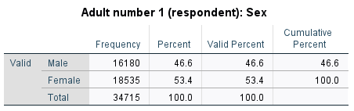

Table 2. Frequency table for ethnicity
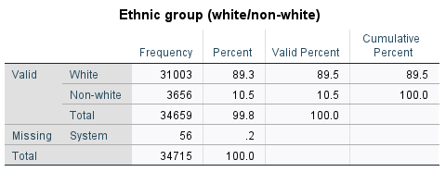

Table 3. Frequency table for household income
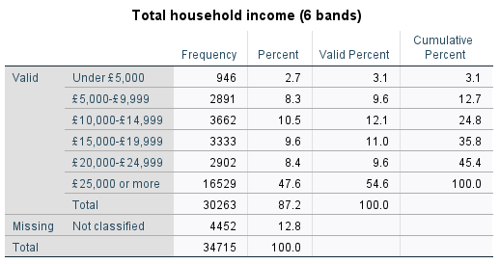

Table 4. Frequency table for PCC contact
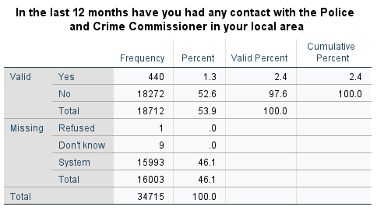

Bivariate Analysis
Table 5. Crosstabulation between sex and PCC contact
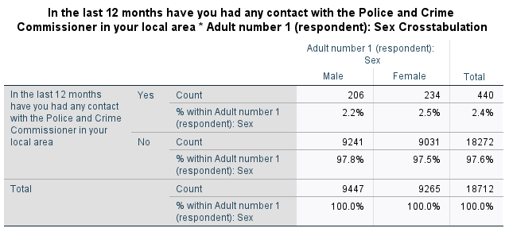

Table 6: Chi Square testing the association between sex and PCC contact
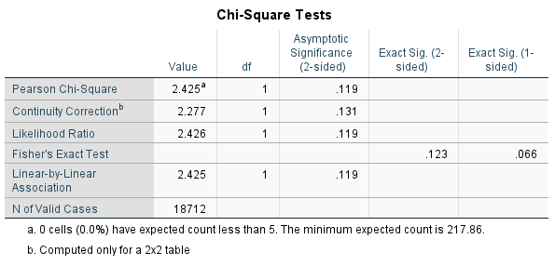

Table 7. Strength of association between sex and PCC contact
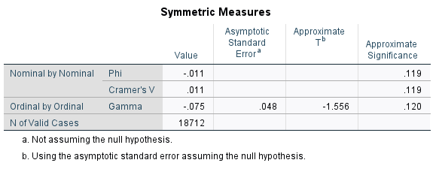

Table 8: Crosstabulation between ethnicity and PCC contact
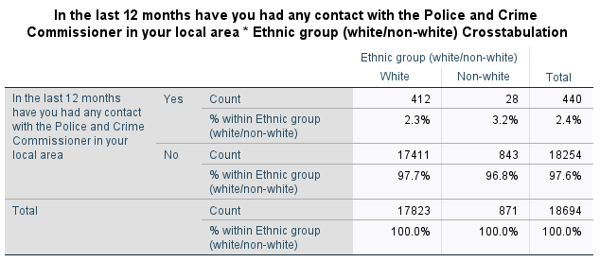

Table 9. Chi Square testing the association between ethnicity and PCC contact
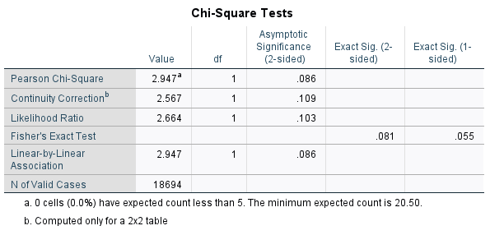

Table 10. Strength of association between ethnicity and PCC contact
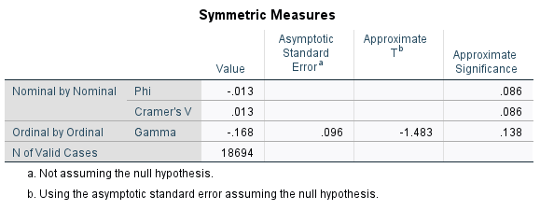

Table 11: Crosstabulation between household income and PCC contact
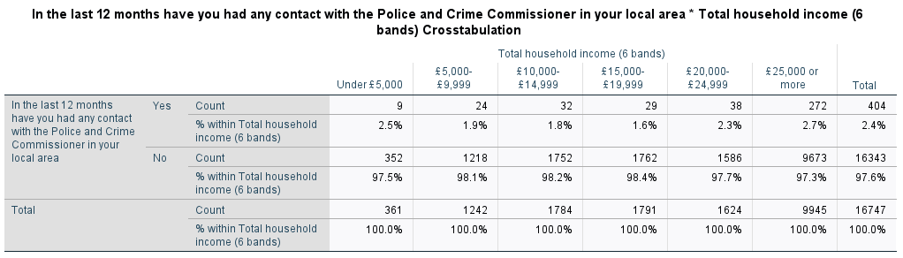

Table 12. Chi Square testing the association between household income and PCC contact
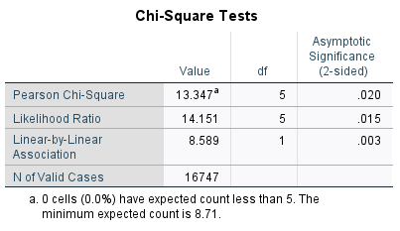

Table 13. Strength of association between household income and PCC contact
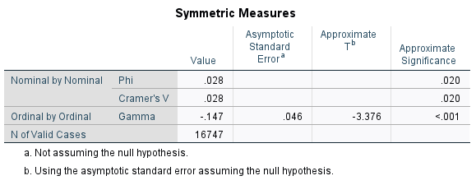

Logistic Regression Analysis
Table 14. Omnibus Tests of Model Coefficients
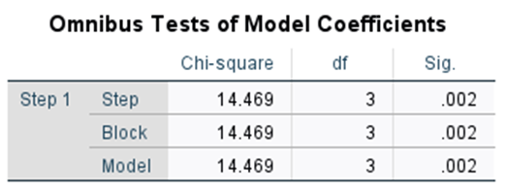

Table 15. Model Summary
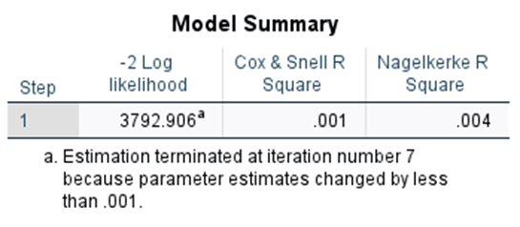

Table 16. Variables in the Equation
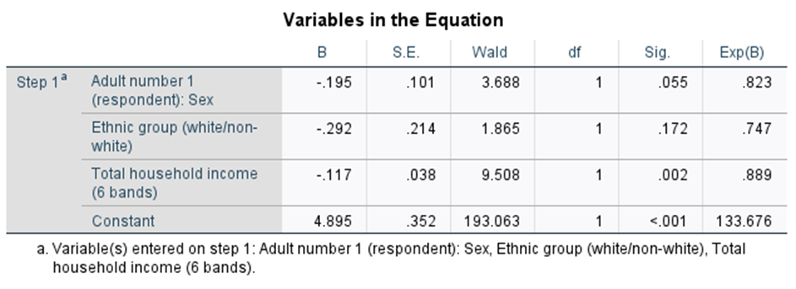

A logistic regression analysis was performed to analyse the effect of sex (sex), ethnicity (ethgrp3a) and household income (hhinc6a) on contact with the PCC. The Nagelkerke R-Square value in Table 15 states that the model explained 0.4% of the variation in the dependant variable (pcccon). Therefore, 0.4% of the variation can be explained by the combination of sex, ethnicity and household income. The model is statistically significant (p = .002).
Table 16 shows that the first independent variable (sex) is not statistically significant in explaining PCC contact (p=.055). The Odds Ratio (ExpB) for sex is 0.823, which indicates decreased odds for an increase in one unit of the independent variable. The second independent variable of ethnicity (ethgrp3a) is also not statistically significant (p=.172), with an Odds Ratio of 0.747.
The third independent variable of household income (consisting of 6 categories: under £5000; £5000 - £9999; £10,000 - £14,999; £15,000 - £19,999; £20,000 - £24,999; £25,000 or more) is statistically significant (p= .002). The Odds Ratio for hhinc6a is 0.889, which indicates decreased odds for an increase in one unit of the independent variable. Therefore, an increase in one unit of the hhinc6a variable (having a higher household income) decreases the odds of not contacting the PCC by a unit of 0.889. Consequently, having a higher household income means the chance of PCC contact is higher.
Table 14 shows that the model is statistically significant (p = .002), therefore the alternative hypothesis (HA) has been accepted, and the null hypothesis (H0) rejected.

Discussion
The objective of this report was to discover if sex, ethnicity and household income influence whether a person contacts their PCC – this logistic regression analysis has shown that together, these variables have a statistically significant effect on PCC contact. The data also suggests that those who have a higher household income are more likely to contact their local Police and Crime Commissioner.
These findings are troubling, as the Police Reform and Social Responsibility Act 2011 Section 14 states, it is the PCC’s duty to obtain the views of the people in that area, though this is clearly not being achieved through the public reaching out to PCCs. As the Stevens Report (2013) shows, those who come into less direct contact with PCCs are less likely to have their concerns addressed. Therefore, those with a lower household income are less likely to have their interests represented by their Police and Crime Commissioner.
Furthermore, the statistical significance of the overall logistic regression model indicates that certain genders and ethnicities are more likely to contact their PCC than others. The Stevens Report suggests that this could result in certain ethnic groups and genders being overlooked by PCCs, and therefore policies being made that do not consider them fully. As Merry et al. (2012) and Keeling (2017) show, this can have disastrous societal effects, such underreporting of crime, and discriminatory police forces.
Further research examining why some members of the public do not contact their PCCs is needed to gain a systematic understanding of the problem. Research exploring the frequency of contact between the Police and Crime Commissioner and other groups in society (such as different religious groups, or nationalities) would aid the understanding of this topic. Gaining a comprehensive understanding of PCC contact will also help to suggest potential ways we can ensure all members of a PCC’s constituency are properly represented.

Conclusion
In conclusion, the data analysis that has been conducted in this report - using the Crime Survey for England and Wales 2017-2018 and a logistic regression analysis - has shown that the variables sex, ethnicity, and household income have a statistically significant effect on whether a person contacts their PCC. It has also been shown that those with a higher household income are more likely to contact their PCC.
This report aimed to begin to provide research on which factors effect whether a person contacts their PCC, as many academics, such as Caless and Owens (2016) and Kirkland (2015), have highlighted the lack of investigation into this area. Further research is needed to fully understand why certain groups do not contact PCCs, as this report has explored the pernicious societal consequences that an unhealthy relationship between police and the public can have.

Word Count: 2183

Reference List
Caless, B. and Owens, J. (2016) Police and Crime Commissioners: The Transformation of Police Accountability. Bristol, Policy Press.
Crawford, A. (2016) The English and Welsh Experiment in Democratic Governance of Policing through Police and Crime Commissioners: A Misconceived Venture or a Good Idea, Badly Implemented? In: Delpeuch, T. and Ross, J.E (eds.) Comparing the Democratic Governance of Police Intelligence. Cheltenham, Edward Elgar Publishing, pp. 116–152.
Dillabough, J.A., Rochez, C. and Balfour, B. (2018) Young People Heating Up in the London Kettle: Reading Between the Fault Lines of Race and Class Wars of the British Urban Riot Scene (1958–2011). In: Trifonas, P.P. and Jagger, S. (eds.) Handbook of Cultural Studies and Education. London, Routledge, pp. 124-151.
Goodman‐Delahunty, J. and Graham, K. (2011) The Influence of Victim Intoxication and Victim Attire on Police Responses to Sexual Assault. Journal of Investigative Psychology and Offender Profiling, 8(1), pp. 22-40.
Joseph–Salisbury, R., Connelly, L. and Wangari-Jones, P. (2020) “The UK is Not Innocent”: Black Lives Matter, Policing and Abolition in the UK. Equality, Diversity and Inclusion: An International Journal, 40(1), pp. 21-28.
Kawalerowicz, J. and Biggs, M. (2015) Anarchy in the UK: Economic Deprivation, Social Disorganization, and Political Grievances in the London Riot of 2011. Social Forces, 94(2), pp. 673-698.
Keeling, P. (2017) No Respect: Young BAME Men, the Police and Stop and Search. Criminal Justice Alliance [Internet]. London, Criminal Justice Alliance. Available from http://criminaljusticealliance. org/wp-content/uploads/2017/06/No-Respect-290617-1. pdf. [Accessed 3rd January 2022].
Kirkland, C. (2015) PCC Elections as a ‘Failed Experiment’: What Lessons can be Learned? The Political Quarterly, 86(3), pp. 403-410.
Loader, I. and Muir, R. (2016) Embracing Police and Crime Commissioners: Lessons from the Past, Directions for the Future. London, The Police Foundation. Available from https://www.police-foundation.org.uk/2017/wp-content/uploads/2017/01/embracing_pccs.pdf [Accessed 10th January 2022].
McDaniel, J.L. (2018) Evaluating the Ability and Desire of Police and Crime Commissioners (PCCs) to Deliver Community-Oriented Policing in Practice. In: Leventakis, G. and Haberfeld, M.R. (eds.) Societal Implications of Community-Oriented Policing and Technology. New York, Springer, pp. 39-46.
Merry, S., Power, N., McManus, M. and Alison, L. (2012) Drivers of Public Trust and Confidence in Police in the UK. International Journal of Police Science and Management, 14(2), pp. 118-135.
Office for National Statistics (2021) Crime Survey for England and Wales 2017-2018. [data set]. SN: 8464. Colchester, UK Data Service. Available from https://beta.ukdataservice.ac.uk/datacatalogue/studies/study?id=8464 [Accessed 2nd January 2022]
Raine, J.W. and Keasey, P. (2012) From Police Authorities to Police and Crime Commissioners: Might Policing Become More Publicly Accountable? International Journal of Emergency Services, 1(2), pp. 122-134.
Roycroft, M. (2016) The Results of Interviews with the Police and Crime Commissioners. In: Roycroft, M. (ed.) Police Chiefs in the UK. Camden, Palgrave Macmillan, pp. 119-148.
Sleath, E. and Bull, R. (2012) Comparing Rape Victim and Perpetrator Blaming in a Police Officer Sample: Differences Between Police Officers With and Without Special Training. Criminal Justice and Behavior, 39(5), pp. 646-665.
Stevens, L. (2013) Policing for a Better Britain: Report of the Independent Police Commission [Internet]. London, Independent Police Commission. Available from http://lgiu.org/wp-content/uploads/2014/01/Policing-for-a-better-Britain-the-Stevens-report.pdf [Accessed 3rd January 2022].
Taylor, S.C. and Gassner, L. (2010) Stemming the Flow: Challenges for Policing Adult Sexual Assault with Regard to Attrition Rates and Under‐Reporting of Sexual Offences. Police Practice and Research: An International Journal, 11(3), pp. 240-255.
The Police Reform and Social Responsibility Act 2011 (c.13) London, TSO.
Tilley, N. and Tseloni, A. (2016) Choosing and Using Statistical Sources in Criminology: What Can the Crime Survey for England and Wales Tell Us? Legal Information Management, 16(2), pp. 78-90.
Uhrig, N. (2016) Black, Asian and Minority Ethnic Disproportionality in the Criminal Justice System in England and Wales [Internet]. London, Ministry of Justice. Available from file:///C:/Users/44793/Downloads/Black-asian-and-minority-ethnic-disproportionality-in-the-criminal-justice-system-in-england-and-wales%20(1).pdf [Accessed 3rd January 2022].
Waterhouse, G.F., Reynolds, A. and Egan, V. (2016) Myths and Legends: The Reality of Rape Offences Reported to a UK Police Force. The European Journal of Psychology Applied to Legal Context, 8(1), pp. 1-10.
Weare, S. (2021) “I Feel Permanently Traumatized by It”: Physical and Emotional Impacts Reported by Men Forced to Penetrate Women in the United Kingdom. Journal of Interpersonal Violence, 36(13-14), pp. 6621-6646.
Wells, H. (2018) The Angered Versus the Endangered: PCCs, Roads Policing and the Challenges of Assessing and Representing ‘Public Opinion’. The British Journal of Criminology, 58(1), pp. 95-113.

