SSC5002M Assessment 2: Does the type of accommodation occupied affect witnessed crime levels?

Introduction
Broken Windows Theory (Wilson and Kelling, 1982) states that when a neighbourhood experiences high levels of criminal activity, the residents witness this behaviour, perpetuating criminality. Over the last decade the police have made significant efforts to reduce this phenomena (O'Brien, Farrell and Welsh, 2019).
McKee, Soaita, and Hoolachan (2020) show that occupants of wealthy neighbourhoods often own their accommodation, whereas occupants of economically deprived areas are more likely to rent, or live rent-free with a family member. As there is no variable in the CSEW 2017-2018 dataset describing the level of economic deprivation a respondent lives in, ‘tenure1’ will be used to indicate this.
This research will attempt to understand if the police have been successful in reducing the level of witnessed crime in economically deprived areas, by comparing results with Weisburd et al. (2015) who examine witnessed crime rates over the last few decades.
This research has significant criminological relevance, as it is important to understand if new policing procedures are successful. If they are not, then potentially millions of pounds are being wasted (Machin and Marie, 2011).

Research Question
In the Crime Survey for England and Wales 2017-2018 dataset, does the way a person occupies their accommodation affect whether they have witnessed a crime?

Variables
The CSEW dataset contains a categorical and nominal variable describing method of occupying accommodation: tenure1 (“In which way do you occupy this accommodation”).
There is also a categorical and nominal variable regarding witnessing crime: witcri (“In the last 12 months, have you witnessed a crime”). These variables will be used to answer the research question.
Statistical test
As both variables are categorical, the appropriate test is chi-squared. This will compare the observed frequencies in each cell of a cross-tabulation table to the expected frequencies if there were no relationship between the method of occupying accommodation, and whether a crime was witnessed in the last year.

Hypothesis
H0: Variable A and Variable B are independent
HA: Variable A and Variable B are not independent

Results

Table 1. Frequency table for witcri
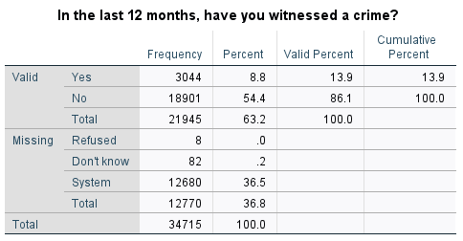

Table 2. Frequency table for tenure1
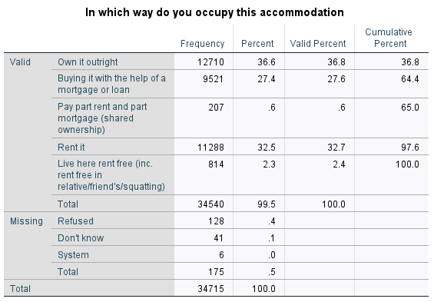

Table 3. Cross-tabulation table describing the relationship between tenure1 and witcri
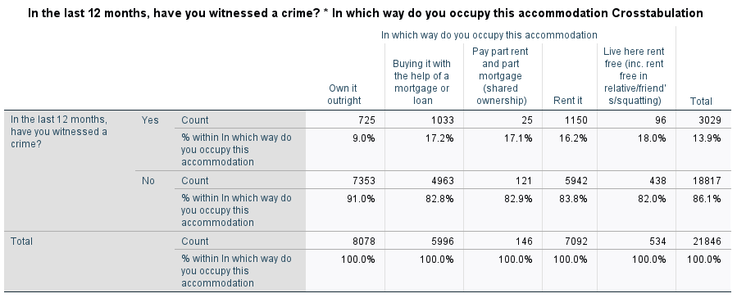

Table 4. Chi Squared test showing whether the association between tenure1 and witcri is significant

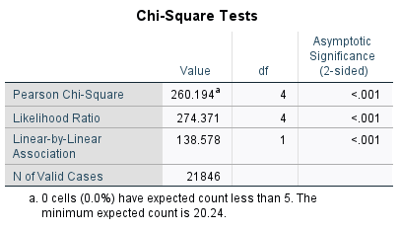

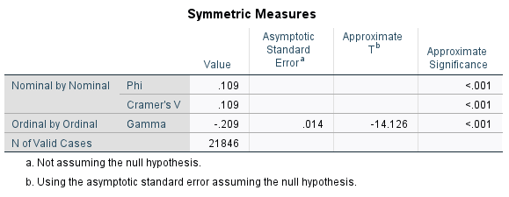
Table 5. Measure of association test showing how strong the association between tenure1 and witcri

Interpretation
A chi-square test for association was conducted between the method of occupying accommodation [tenure1] and whether crime was witnesses in the last 12 months [witrci]. All expected cell frequencies were greater than five. There was a statistically significant association between tenure1 and witcri: χ2(1) = 260.2, p = <.001. There was a weak association between tenure1 and witcri, Cramer’s V = 0.109.

Conclusion
The research found that respondents who owned their accommodation witnessed less crime than those who rented or partially rented their accommodation. The null hypothesis was rejected in favour of the alternative hypothesis.
These findings are consistent with Weisburd et al. (2015), who state that police attempts to interrupt Broken Windows Theory have been insufficient to reduce witnessed crime. This culmination of evidence suggests that new policy implementation is needed to halt Broken Windows Theory, as current strategies are inadequate.

Word count: 544

References
Machin, S. and Marie, O. (2011) Crime and Police Resources: The Street Crime Initiative. Journal of the European Economic Association, 9(4), pp. 678-701
McKee, K., Soaita, A.M. and Hoolachan, J. (2020) ‘Generation Rent’ and the Emotions of Private Renting: Self-worth, Status and Insecurity Amongst Low-income Renters. Housing Studies, 35(8), pp. 1468-1487
O'Brien, D.T., Farrell, C. and Welsh, B.C. (2019) Broken (Windows) theory: A Meta-Analysis of the Evidence for the Pathways from Neighbourhood Disorder to Resident Health Outcomes and Behaviours. Social Science & Medicine, 228, pp. 272-292
Office for National Statistics (2021) Crime Survey for England and Wales 2017-2018. [data set]. SN: 8464. Colchester, UK Data Service. Available from https://beta.ukdataservice.ac.uk/datacatalogue/studies/study?id=8464 [Accessed 26th November 2021]
Weisburd, D., Hinkle, J.C., Braga, A.A. and Wooditch, A. (2015) Understanding the Mechanisms Underlying Broken Windows Policing: The Need for Evaluation Evidence. Journal of Research in Crime and Delinquency, 52(4), pp. 589-608
Wilson, J.Q. and Kelling, G.L. (1982) Broken Windows: The Police and Neighbourhood Safety. Atlantic Monthly, 249, pp. 29-38

